**INFOHUB: HELPDESK FOR GOVT EMPLOYEES USING CONVERSATIONAL AI**

**INNOVATIVE PRODUCT DEVELOPMENT REPORT**

# Submitted by

**C.Gayathri B.Ashritha G,Kaveri P.Sushma**

**21RH1A6711 21RH1A6704 21RH1A6724 21RH1A6753**

**UNDER THE GUIDANCE OF**

**Ms.D.Srivalli**

**Assistant Professor**

**Dept. of CSE-DS**

***in partial fulfillment of the Academic Requirements for the Degree of***

**BACHELOR OF TECHNOLOGY**

# COMPUTER SCIENCE & ENIGNEERING-DATA SCIENCE



**MALLA REDDY ENGINEERING COLLEGE FOR WOMEN**

**(Autonomous Institution-UGC, Govt. of India**)

**Accredited by NBA & NAAC with ‘A’ Grade**

**National Ranking by NIRF Innovation – Rank band (151-300), MHRD, Govt. of India**

Approved by AICTE, Permanently Affiliated to JNTUH, ISO 9001:2015 Certified Institution **Maisammaguda, Dhulapally, Secunderabad, Kompally-500100.** www.mallareddyecw.com

**2023-24**

## MALLA REDDY ENGINEERING COLLEGE FOR WOMEN



**(Autonomous Institution-UGC, Govt. of India**)

**Accredited by NBA & NAAC with ‘A’ Grade**

**National Ranking by NIRF Innovation – Rank band (151-300), MHRD, Govt. of India**

Approved by AICTE, Permanently Affiliated to JNTUH, ISO 9001:2015 Certified Institution **Maisammaguda, Dhulapally, Secunderabad, Kompally-500100.** www.mallareddyecw.com

**DEPARTMENT OF CSE - DS**

### CERTIFICATE

This is to certify that the Innovative Product Development work **INFOHUB, HELPDESK FOR GOVERNEMNT EMPLOYEES** carried out by **C.Gayathri(21RH1A6711), B.Ashritha(21RH1A6704), G.Kaveri(21RH1A6724), P.Sushma(21RH1A6753)** in partial fulfillment for the award of degree of BACHELOR OF TECHNOLOGY in CSE - DS, Malla Reddy Engineering college for Women, Hyderabad during the academic year 2023-2024.

|  |  |
| --- | --- |
|  |  |
| **Ms.D.Srivalli** | **Dr. V.Pradeep** |
| **Assistant Professor** | **Head of the Department-DS** |

**External Examiner**

## MALLA REDDY ENGINEERING COLLEGE FOR WOMEN

**(Autonomous Institution-UGC, Govt. of India**)

**Accredited by NBA & NAAC with ‘A’ Grade**

**National Ranking by NIRF Innovation – Rank band (151-300), MHRD, Govt. of India**

Approved by AICTE, Permanently Affiliated to JNTUH, ISO 9001:2015 Certified Institution **Maisammaguda, Dhulapally, Secunderabad, Kompally-500100.** www.mallareddyecw.com

### Department of CSE –DS DECLARATION

We hereby declare that the Innovative Product Development entitled **INFOHUB: HELPDESK FOR GOVERNMENT EMPLOYEES** submitted to Malla Reddy Engineering College for Women affiliated to Jawaharlal Nehru Technological University, Hyderabad (JNTUH) for the award of the Degree of Bachelor of Technology in CSE-DS is a result of original research work done by us. It is further declared that the Innovative Product Development report or any part thereof has not been previously submitted to any University or Institute for the award of Degree.

**C.Gayathri(21RH1A6711)**

**B.Ashritha(21RH1A6704)**

**G.Kaveri(21RH1A6724)**

**P.Sushma(21RH1A6753)**

### ACKNOWLEDGEMENT

We feel ourselves honored and privileged to place our warm salutation to our college **Malla Reddy Engineering College for Women** and **Department of CSE-DS** which gave us the opportunity to have expertise in engineering and profound technical knowledge.

We would like to deeply thank our Honorable Minister of Telangana State **Sri**.**Ch. Malla Reddy Garu,** founder chairman MRGI, the largest cluster of institutions in the state of Telangana for providing us with all the resources in the college to make our project success.

We wish to convey gratitude to our **Principal Dr. Y. Madhavee Latha,** for providing us with the environment and mean to enrich our skills and motivating us in our endeavor and helping us to realize our full potential.

We would like to thank **Prof. A. Radha Rani**, Director of Computer Science and Engineering & Information Technology for encouraging us to take up a project on this subject and motivating us towards the Project Work.

We express our sincere gratitude to **Dr. V. Pradeep, Head of the Department** of CSE–DS for inspiring us to take up a project on this subject and successfully guiding us towards its completion.

We would like to thank our guide **Ms.D.Srivalli, Assistant Professor** and all the Faculty members for their valuable guidance and encouragement towards the completion of our project work.

**With Regards and Gratitude**

**C.Gayathri(21RH1A6711)**

**B.Ashritha(21RH1A6704)**

**G.Kaveri (21RH1A6724)**

**P.Sushma (21RH1A6753)**

**ABSTRACT**

This abstract outlines the establishment and operation of a Helpdesk tailored specifically for government employees. In today's digital age, government agencies are continually striving to improve their services and streamline internal processes. The Government Employee Helpdesk serves as a centralized support hub, providing assistance and guidance to government workers in navigating various administrative and technical challenges. This initiative aims to enhance service efficiency, increase productivity, and ultimately empower government employees to better serve the public. This abstract provides a brief overview of the Helpdesk's purpose, features, and anticipated benefits for government agencies and their employees.

#### INDEX

|  |  |
| --- | --- |
| **1**.**INTRODUCTION** |  |
| 1.1 Project definition | 01 |
| 1.2 Project Overview | 01 |
| 1.3 Software Requirements | 01 |
| 1.4 Hardware Requirements | 01 |
| **2**.**LITERATURE SURVEY** |  |
| 2.1 System Architecture | 02 |
| 2.2 Existing System | 03 |
| 2.3 Proposed System | 03 |
| 2.4 Advantages | 03 |
| 2.5 Disadvantages | 04 |
| **3. METHODOLOGY** | 05-06 |
| **4. SOURCE CODE** | 07-16 |
| **5. RESULTS** | 17-20 |
| **6. CONCLUSION** | 21 |
| **7. FUTURE SCOPE** | 21 |
| **8. REFERENCES** | 22 |

#### CHAPTER 1

#### INTRODUCTION

##### PROJECT DEFINITION

##### In today's digital age, government helpdesks are often inundated with inquiries, leading to long response times and frustrated citizens.The lack of 24/7 support and delays in addressing critical concerns are significant pain points.The goal is to empower citizens with an intelligent virtual assistant that can address their queries, provide information, and guide them through government processes effectively, ultimately enhancing the overall efficiency and effectiveness of government service delivery.

##### 1.2 PROJECT OVERVIEW

This project aims to develop 'Infohub,' a chatbot designed to revolutionize government helpdesk services by offering instant responses, accurate information, and a seamless user experience. Chatbots have demonstrated the ability to empower users by providing self-service options, guiding them through processes, and ensuring they receive accurate and up-to-date information.

##### 1.3 SOFTWARE REQUIREMENTS

The software requirements for the project include:

1. Python for programming.(version 3.6+)

2. installed pip

3. rasa framework

##### 1.4 HARDWARE REQUIREMENTS

The hardware requirements involve a standard computer with:

1. Sufficient processing power to run machine learning algorithms.

2. Sufficient storage space for datasets and model parameters.

ss

#### CHAPTER 2

##### LITERATURE SURVEY

**SYSTEM ARCHITECTURE**

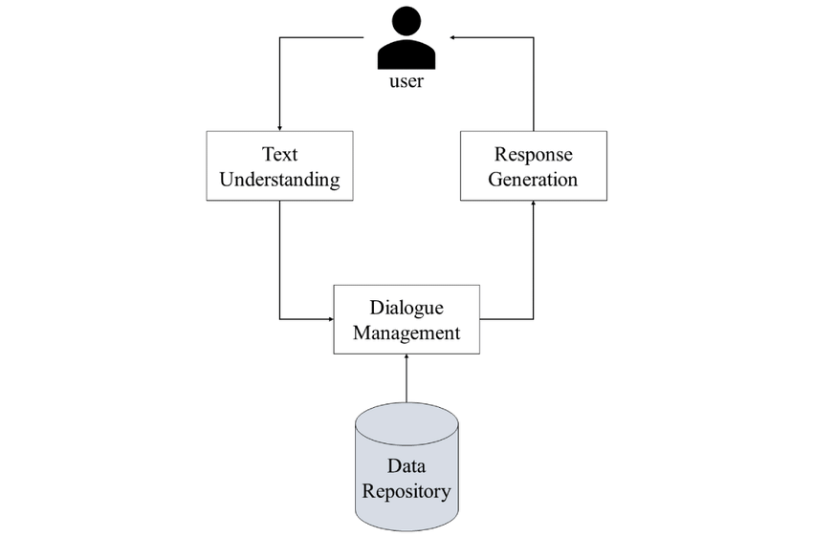

**REASONS FOR EVOLUTION OF THIS PROJECT:**

This is the literature survey based on the problem statement:

1.Citizen-Government Interaction Challenge:

Various studies have documented the challenges faced by citizens when interacting with government helpdesks, including long response times and a lack of 24/7 support.

2. Increasing Digitalization:

As societies increasingly digitize, there is a growing demand for government services to be accessible online, necessitating innovative solutions for efficient information dissemination.

3.The Rise of Chatbots:

Recent research has explored the use of chatbots in various sectors, including customer support and healthcare, to enhance user experiences and provide quick, automated responses.

4.Efficiency Enhancement with Chatbots:

Studies have shown that chatbots can significantly reduce the response time for user inquiries, leading to greater satisfaction and resource savings.

5. User Empowerment and Engagement:

Chatbots have demonstrated the ability to empower users by providing self-service options, guiding them through processes, and ensuring they receive accurate and up-to-date information.

6. Government Service Delivery Improvements:

The integration of chatbots in government helpdesks can streamline service delivery, reduce the burden on human operators, and ultimately enhance the overall efficiency and effectiveness of government-citizen interactions.

##### EXISTING SYSTEM

• May lack in-depth knowledge of government processes

• Limited integration with e government databases and systems.

• Response times and accuracy can vary.

• Typically not tailored specifically for government helpdesks.

##### PROPOSED SYSTEM

The proposed system is creating an Infohub helpdesk system for government employees involves designing a comprehensive information and support platform that can understand the process of any particular government department.

**ADVANTAGES**

Implementing an Infohub helpdesk system for government employees offers several advantages:

1. Efficient Support: Employees can easily access support and information, reducing the time and effort required to resolve issues or find information

2. Centralized Information: A centralized repository of official documents and resources ensures consistent access to accurate information.

3. Improved Communication: The system enhances communication between employees and support agents, fostering better collaboration.

4. Enhanced Productivity: Quick issue resolution and access to knowledge boost employee productivity.

5. Cost Savings: Reduced need for physical support centers and printed materials can lead to cost savings.

6. Data Security: Proper security measures can protect sensitive government data from unauthorized access

7. Analytics and Insights: Data analytics tools can provide insights into support trends and areas that need improvement.

8. Scalability: The system can adapt to the changing needs of the government workforce as it grows or evolves.

9. Feedback Loop: Employees can provide feedback, which helps in continuously improving support services.

10. Accessibility: Mobile access ensures support is available to employees wherever they are.

11. Consistency: The system ensures that all employees receive the same level of support and access to information.

12. Compliance: The system can be designed to meet regulatory and compliance requirements.

13. Reduced Workload: Automation of common queries and ticket routing reduces the workload on support agents.

14. User Empowerment: Employees can find answers to their questions independently, promoting self-sufficiency.

15. Emergency Response: The system can be a valuable tool in emergency situations, providing important information.

##### DISADVANTAGES

While an Infohub helpdesk system for government employees offers many advantages, it's essential to consider potential disadvantages and challenges:

1. Resistance to Change: Some employees may resist the transition to a new system, causing delays in adoption and productivity.

2. Maintenance and Upkeep: Ongoing maintenance and updates are required, which can be resource-intensive.

3. Data Security Risks: Storing sensitive government data requires robust security measures to prevent breaches and data leaks.

4. Privacy Concerns: Employee data privacy must be carefully managed to avoid breaches or misuse of personal information.

#### CHAPTER 3

#### METHODOLOGY

Helpdesk for government employees and department is built based on conversational AI, a type of AI that can simulate human conversation. Here are some of the most common approaches to developing chatbots:

1. Custom Development with Programming Languages: Develop a chatbot from scratch using programming languages like Python, Node.js, Java, or Ruby.
2. Bot Development Platforms: Use bot development platforms like Microsoft Bot Framework, Botpress, or SAP Conversational AI.
3. Conversational AI Frameworks: Leverage conversational AI frameworks such as Rasa or Dialogflow. These frameworks are designed specifically for chatbot development and provide NLP, dialogue management, and integration capabilities.
4. Low-Code/No-Code Platforms: Create chatbots with low-code or no-code platforms like Chatfuel, Tars, or ManyChat.

Few key terminologies to be understood:

1. Intents: An intent represents the goal or purpose behind a user's input. Chatbots use intent recognition to understand what the user is trying to accomplish.
2. Entity: An entity is a piece of information within a user's input that is relevant to fulfilling the user's intent. For example, in the sentence "Book a flight to New York," "New York" is an entity representing the destination.
3. Dialog Flow: The dialog flow is the structure and sequence of interactions between the chatbot and the user, forming a conversation.
4. Utterance: An utterance is a single statement or message from a user. It can be a question, command, or any other message.
5. Response: A response is what the chatbot generates and sends back to the user as a reply to their input.

Our preferred approach here is through bot development platforms i.e, rasa framework.

Steps for developing a chatbot using rasa:

1. Installation:

Make sure that python is installed in the system.(version 3.6+).

1. Create python virtual environment

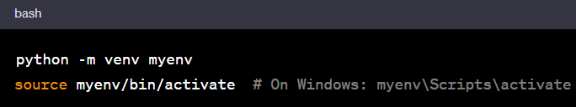

1. Install rasa using pip

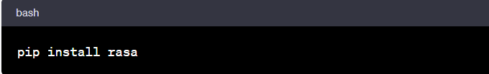

1. Create a new rasa project

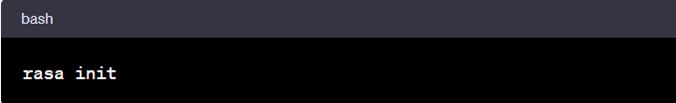

1. Define Your Assistant's Domain

In the Rasa project directory, you'll find a domain.yml file. Define your chatbot's domain by specifying intents, entities, actions, responses, and templates.

Create custom actions in Python (if needed) by implementing them in the actions.py file.

1. Training Data

Create training data files, including NLU (Natural Language Understanding) data and dialogue data in the data directory.

For NLU data, create a nlu.yml file to define intents and examples.

For dialogue data, create a stories.yml file to define conversation flows.

1. **Training the Chatbot**

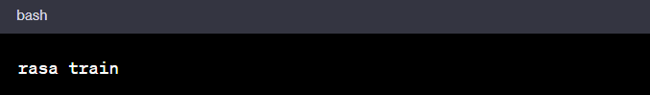

1. Run the chatbot:

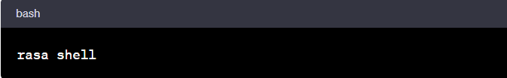

1. For the chatbot to run on the browser



**CHAPTER 4**

### SOURCE CODE

🡪**Code for nlu.yml**

- intent: greet

examples: |

- hey

- hello

- hi

- hello there

- good morning

- good evening

- moin

- hey there

- let's go

- hey dude

- goodmorning

- goodevening

- good afternoon

- intent: goodbye

examples: |

- good afternoon

- cu

- good by

- cee you later

- good night

- bye

- goodbye

- have a nice day

- see you around

- bye bye

- see you later

- intent: affirm

examples: |

- yes

- y

- indeed

- of course

- that sounds good

- correct

- intent: deny

examples: |

- no

- n

- never

- I don't think so

- don't like that

- no way

- not really

- intent: mood_great

examples: |

- perfect

- great

- amazing

- feeling like a king

- wonderful

- I am feeling very good

- I am great

- I am amazing

- I am going to save the world

- super stoked

- extremely good

- so so perfect

- so good

- so perfect

- intent: mood_unhappy

examples: |

- my day was horrible

- I am sad

- I don't feel very well

- I am disappointed

- super sad

- I'm so sad

- sad

- very sad

- unhappy

- not good

- not very good

- extremly sad

- so saad

- so sad

- intent: bot_challenge

examples: |

- are you a bot?

- are you a human?

- am I talking to a bot?

- am I talking to a human?

- intent: my_name_is

examples: |

- [Shariq Ayaz] (person)

- I am [Areesha] (person)

- I am [Ashna] (person)

- I'm [Aliyah] (person)

- I am [Rahil Inzamam] (person)

- My name is [Jamal Anjum] (person)

- My name is [Nazin] (person)

- I am [Sana] (person)

- Myself [Ahad] (person)

- This side [Samad] (person)

- intent: casual_questions

examples: |

- How are you?

- How are you doing?

- How is life going?

- intent: casual_conversation

examples: |

- What are you doing?

- What's up?

- intent: government_benefits

examples: |

- What are the retirement benefits for government employees?

- Tell me about healthcare benefits.

- How can I apply for government housing benefits?

- intent: leave_application

examples: |

- I want to apply for leave.

- How do I request a leave of absence?

- intent: tech_support

examples: |

- My computer is not working. Can you help?

- I need technical support for my government laptop.

- intent: salary_query

examples: |

- How do I access my salary statement?

- Can you provide information about tax deductions?

- What is the pay schedule for government employees?

- intent: report_issue

examples: |

- I want to report a problem in my office.

- There is a leak in the government building. Please fix it.

- Report an issue with the heating system.

🡪 **Code for rules.yml file**

version: "2.0"

# Import necessary libraries and modules

import logging:

from rasa.core.agent import Agent:

from rasa.core.interpreter import RasaNLUInterpreter:

from rasa.core.policies import MemoizationPolicy, KerasPolicy:

from rasa.core.policies.mapping_policy import MappingPolicy:

rules:

- rule: Say goodbye anytime the user says goodbye

steps:

- intent: goodbye

- action: utter_goodbye

- rule: Say 'I am a bot' anytime the user challenges

steps:

- intent: bot_challenge

- action: utter_iamabot

# Create a custom action to provide responses

class ActionGovernmentBenefits:

def name(self):

return "action_government_benefits"

def run(self, dispatcher, tracker, domain):

# Your code to fetch and provide information on government benefits

response = "Here is some information about government benefits..."

dispatcher.utter_message(response)

# Initialize the Rasa agent with policies

def run_bot(serve_forever=True):

interpreter = RasaNLUInterpreter("path/to/your/nlu/model")

agent = Agent.load("path/to/your/core/model", interpreter=interpreter)

if serve_forever:

agent.handle_channel("your_channel_input")

if _name_ == '_main_':

logging.basicConfig(level="INFO")

run_bot()

🡪**Code for stories.yml file**

version: "2.0"

stories:

- story: happy path

steps:

- intent: greet

- action: utter_greet

- intent: mood_great

- action: utter_happy

- story: sad path 1

steps:

- intent: greet

- action: utter_greet

- intent: mood_unhappy

- action: utter_cheer_up

- action: utter_did_that_help

- intent: affirm

- action: utter_happy

- story: sad path 2

steps:

- intent: greet

- action: utter_greet

- intent: mood_unhappy

- action: utter_cheer_up

- action: utter_did_that_help

- intent: deny

- action: utter_goodbye

- story: my_name_is path

steps:

- intent: my_name_is

- action: utter_my_name_is

- story: casual_questions path

steps:

- intent: casual_questions

- action: utter_casual_questions

- story: casual_conversation path

steps:

- intent: casual_conversation

- action: utter_casual_conversation

- story: ask_apply_online path

steps:

- intent: ask_apply_online

- action: utter_ask_apply_online

- story: ask_government_benefits path

steps:

- intent: government_benefits

- action: utter_government_benefits

- story: ask_leave_application path

steps:

- intent: leave_application

- action: utter_leave_application

- story: ask_tech_support path

steps:

- intent: tech_support

- action: utter_tech_support

- story: ask_report_issue path

steps:

- intent: report_issue

- action: utter_report_issue

- story: ask_salary_query path

steps:

- intent: salary_query

- action: utter_salary_query

🡪 **Code for domain.yml file**

version: "2.0"

intents:

- greet

- goodbye

- affirm

- deny

- mood_great

- mood_unhappy

- bot_challenge

- my_name_is

- ask_apply_online

- government_benefits

- leave_application

- tech_support

- salary_query

- report_issue

responses:

utter_greet:

- text: "Hey! How are you?"

utter_cheer_up:

- text: "Here is something to cheer you up:"

image: "https://i.imgur.com/nGF1K8f.jpg"

utter_did_that_help:

- text: "Did that help you?"

utter_happy:

- text: "Great, carry on!"

utter_goodbye:

- text: "Bye"

utter_iamabot:

- text: "I am a bot, powered by Rasa."

utter_my_name_is:

- text: "Nice to meet you {person}"

utter_casual_questions:

- text: "I am great, thank you for asking :)"

utter_casual_conversation:

- text: "Nothing much! just waiting for your reply!!"

utter_ask_apply_online:

- text: "MRECW provides offline as well as online admission procedure. Online admission procedure focuses on CUCET examination. Apply Now on 'https://www.cuchd.in/admissions/how-to-apply.php'!"

utter_government_benefits:

- text: "You can check your benefits by visiting HR department or the official employee portal"

utter_leave_application:

- text: "To request leave, please fill out the leave request form and submit it to your supervisor"

utter_tech_support:

- text: "I'm here to help with technical support for government employees. Please let me know the issue you're facing."

utter_salary_query:

- text: "Thank you for reaching out with your salary query. I'm here to help. Please provide me with more details about your salary-related question, such as the specific month or year you'd like to inquire about or the type of information you need."

utter_report_issue:

- text: "Thank you for reporting the issue. We take your concerns seriously. Please provide more information about the issue you're facing. The more details you can provide, the better we can assist you."

session_config:

session_expiration_time: 60

carry_over_slots_to_new_session: true

🡪**HTML code**

<!DOCTYPE html>

<html lang="en">

<head>

<link rel="stylesheet" href="home.css">

<link rel="stylesheet" href="../all.css">

<meta charset="UTF-8">

<meta name="viewport" content="width=device-width, initial-scale=1.0">

<title>INFOHUB</title>

<style>

body{

font-family: Arial, sans-serif;

margin: 0;

padding: 0;

}

header {

background-color: #8e9c9a;

color: #fff;

text-align: center;

padding: 20px;

}

nav {

background-color: #444;

text-align: center;

padding: 10px;

}

nav ul {

list-style: none;

margin: 0;

padding: 0;

}

nav li {

display: inline;

margin: 0 20px;

}

.container {

max-width: 800px;

margin: 0 auto;

padding: 20px;

}

</style>

</head>

<body>

<div id="rasa-chat-widget" data-websocket-url="http://localhost:5005/socket.io"></div>

<script src="https://unpkg.com/@rasahq/rasa-chat" type="application/javascript"></script>

<header>

<h1>INFOHUB:chatbot for government employees</h1>

</header>

<div class="main-box">

<h1>INFOHUB</h1>

<p>Helpdesk for government employees</p>

</div>

</body>

</html>

🡪**CSS code**

.main-box{

width: 100%;

height: 80vh;

background-image: linear-gradient(#000000bb, #000000bb), url(2.avif);

background-position: center;

background-size: cover;

background-repeat: no-repeat;

color: #ffffff;

text-align: center;

padding-top: 30vh;

}

.main-box h1{

word-spacing: 8px;

margin-bottom: 15px;

font-family: serif;

}

.main-box p{

font-family: "Century Gothic", sans-serif;

font-size: 32px;

letter-spacing: 1px;

margin-bottom: 40px;

}

.main-box button{

padding: 10px;

border: none;

outline: none;

background: none;}

**CHAPTER 5**

### RESULTS

**INPUT**

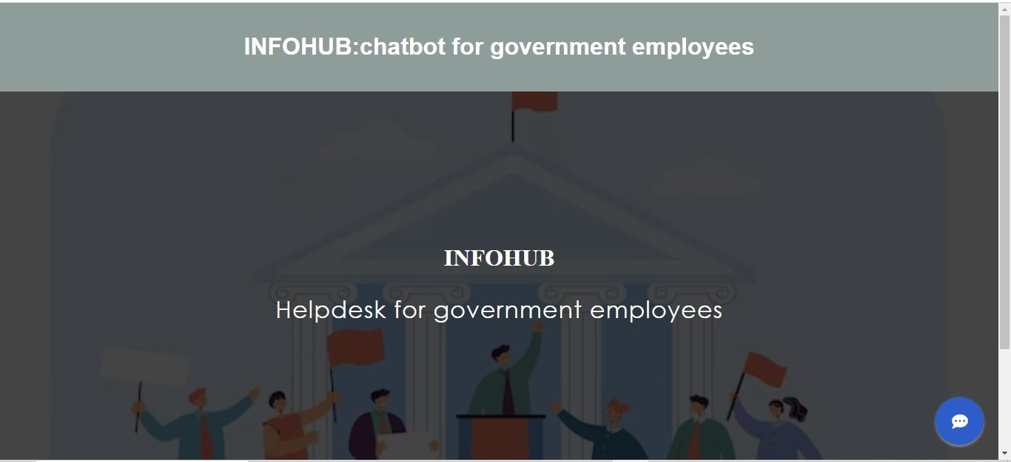

**OUTPUT**

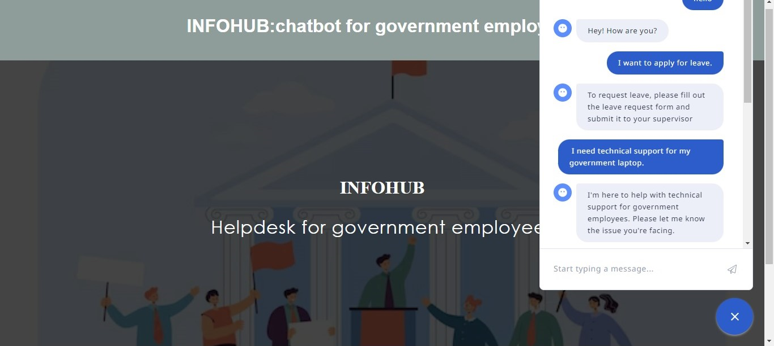

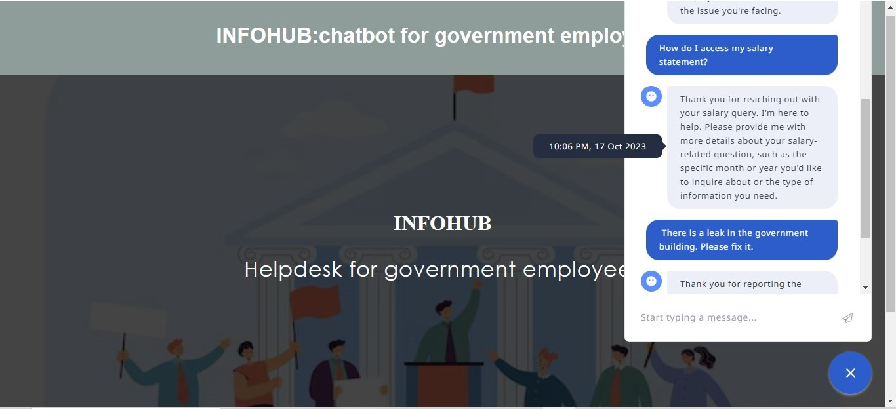

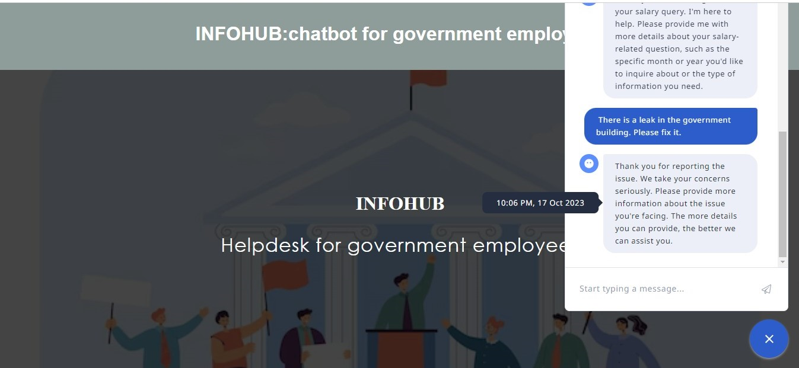

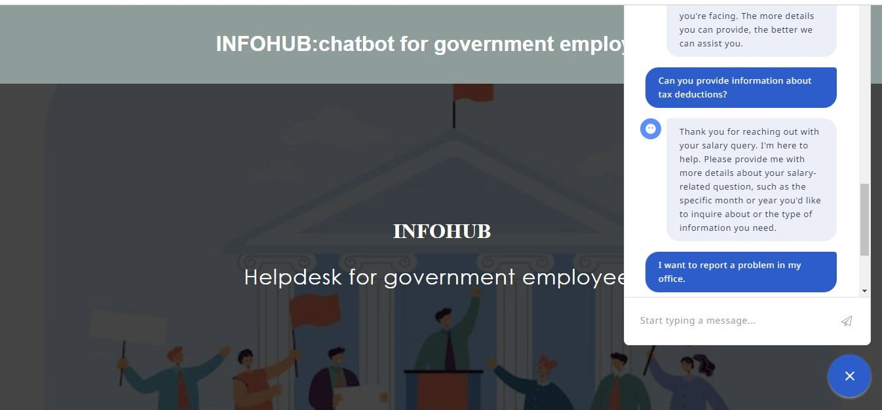

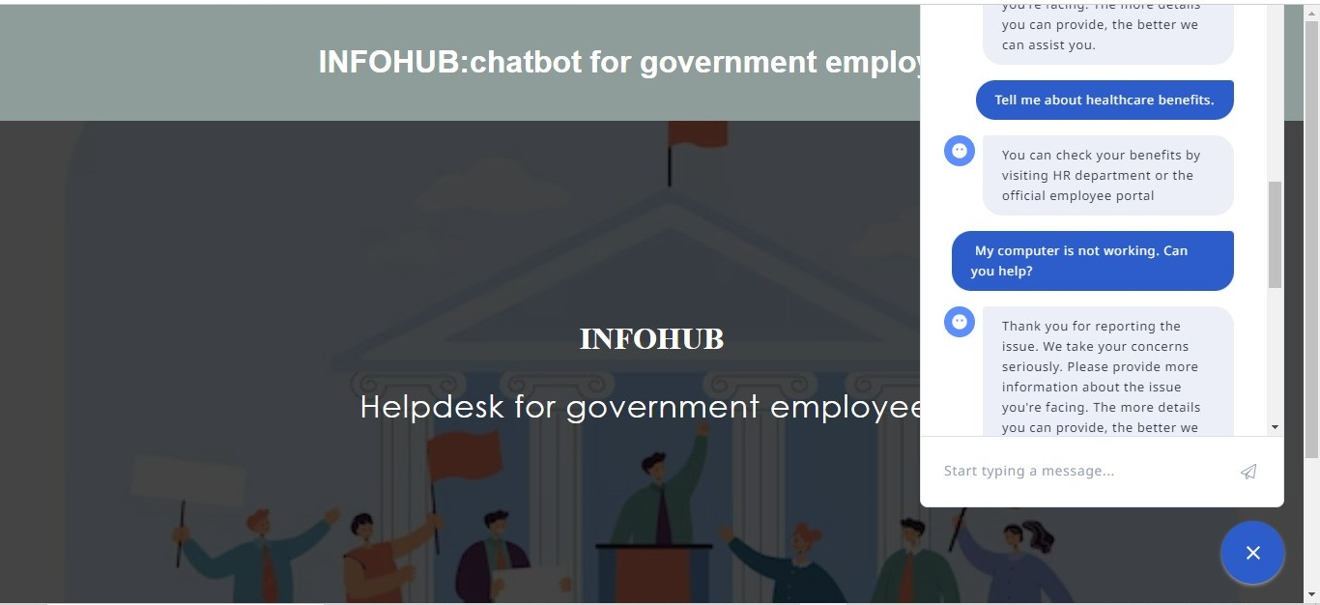

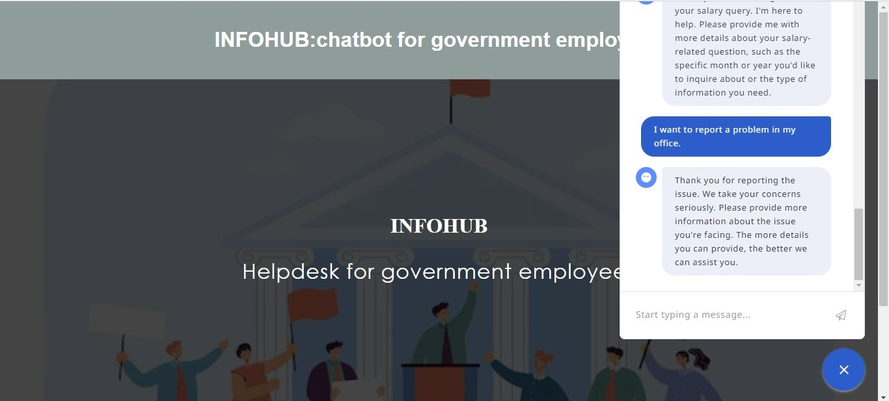

**CHAPTER 6**

**CONCLUSION**

Our Infohub government helpdesk chatbot is a powerful tool designed to streamline access to government services and information. It's user-friendly, efficient, and available 24/7. By utilizing this chatbot, we aim to make government resources more accessible to the public. If you have any questions or would like to explore this further, please feel free to reach out. Your engagement is vital to us, and we look forward to enhancing our services based on your feedback. Thank you for your time and attention today.

### 

### FUTURE SCOPE

The future scope for Infohub, a government helpdesk chatbot, is filled with potential for serving citizens and improving government-citizen interactions. Here are some areas for future development:

1. Wider Service Coverage: Expand the range of services that Infohub can assist citizens with, including tax inquiries, permit applications, and more.

2. Multilingual Support: Enable Infohub to communicate in multiple languages to cater to a diverse population.

3. Voice and Speech Recognition: Incorporate voice and speech recognition capabilities to allow citizens to interact with Infohub via voice commands.

4. Integration with Government Portals: Enhance integration with government websites and services, enabling Infohub to help citizens navigate and complete online processes seamlessly.

5. Real-time Updates and Alert: Implement a system for real-time notifications and updates on government announcements, events, and emergency alerts.

6. Personalization: Use AI to provide personalized assistance and recommendations based on citizens' previous interactions and preferences.

7. Feedback Mechanism: Collect feedback from citizens to continuously improve the chatbot's performance and user experience.

**CHAPTER 7**

### REFERENCES

* <https://towardsdatascience.com/building-a-chatbot-with-rasa-3f03ecc5b324>
* <https://rasa.com/blog/intents-entities-understanding-the-rasa-nlu-pipeline/>
* <https://rasa.com/docs/rasa/domain/>
* <https://rasa.com/docs/rasa/stories/>